**Communication**

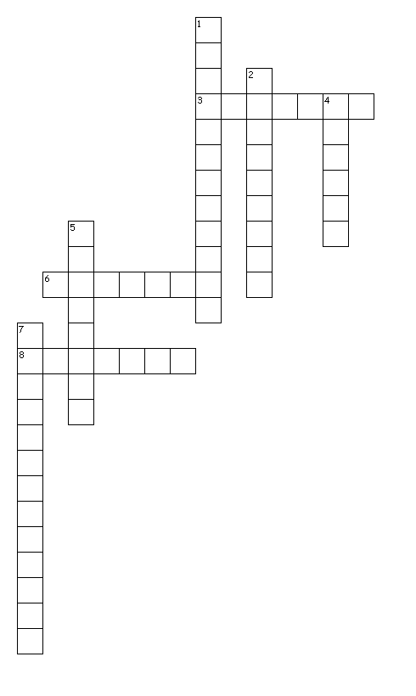

**Across**

3. This type of communication always includes feedback from sender to receiver.

6. What form of communication besides spoken is considered verbal communication?

8. Type of communication that is linear or a straight line from sender to receiver.

**Down**

1. These are things that a good listener needs to be aware of and guard against while listening, such as accent, language style, speaker's mannerisms, or appearance.

2. Body language, physical appearance, or vocal tones are which parts of communication?

4. This type of listener is maintaining eye contact with the speaker & and concentrating on what the speaker is saying, even gives verbal & non-verbal responses.

5. Blocks that keep the receiver and sender from communicating.

7. The process of transferring signals/messages between sender & receiver.